1. Git clone https://github.com/vnarayaj/nifitrucking.git
2. Click on the canvas and click on the configuration button on the leftpane to get the below screen



1. Click on controller services tab
2. Click on the + button to add a new controller service and choose HortonworksSchemaRegistry
3. Click on the edit (pencil) icon next to the HortonworksSchemaRegistry

Click on the settings tab and change the name to HWX Schema Registry

1. Click on the properties tab
2. Set the registry url to http://<host>:7788/api/v1 (the server and port can be obtained from ambari. Default port for registry is 7788) and click ok and apply

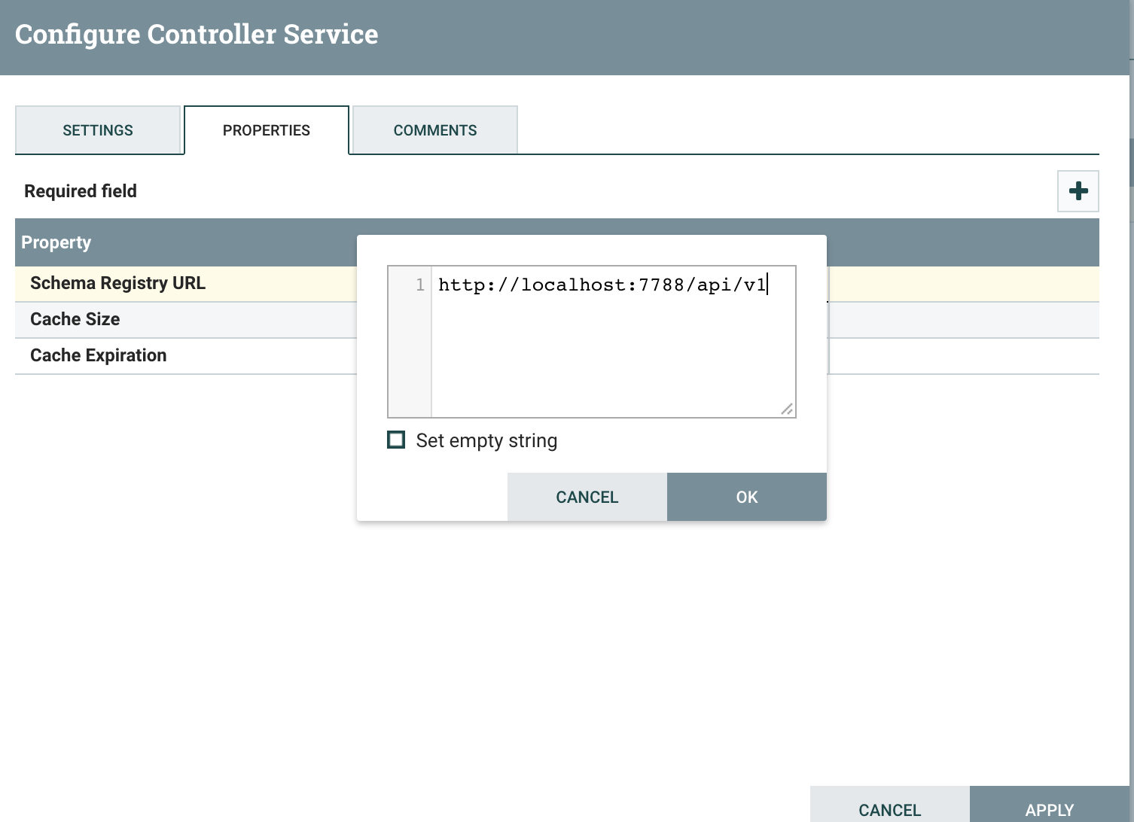

1. On the right column click on the lightning icon to enable the controller

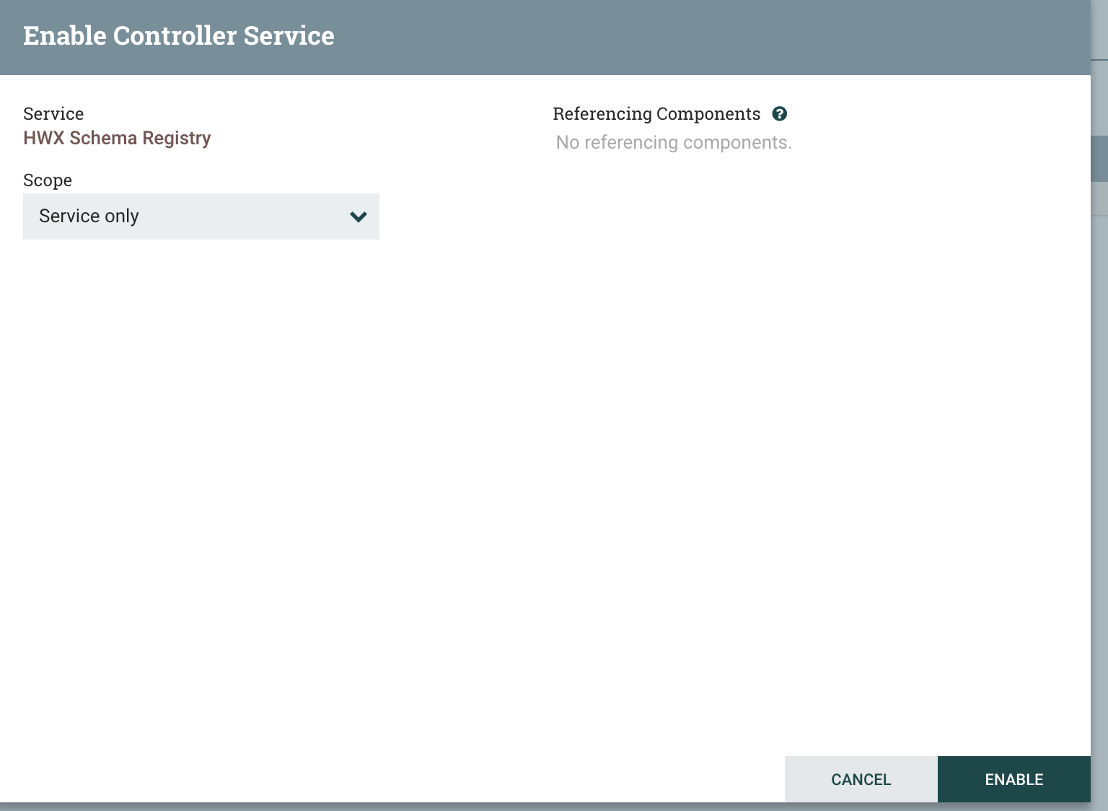

1. Click on + again and choose the avro record writter
2. Click on the settings icon next to the controller and go to the settings tab and Change the name to “AvroRecordWriter - Traffic Data”
3. click on properties tab and set as below

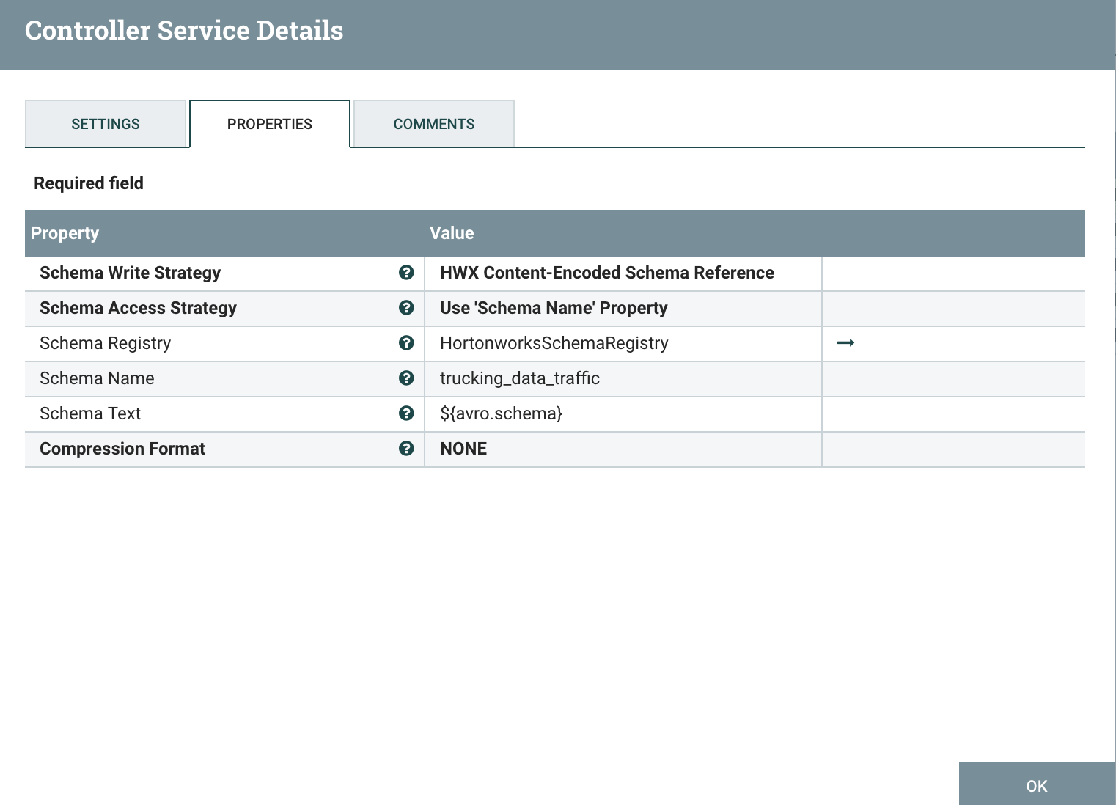

1. Follow a similar approach to add another avro record writer , set the name to AvroRecordWriter - Truck Data
2. and set the properties as below

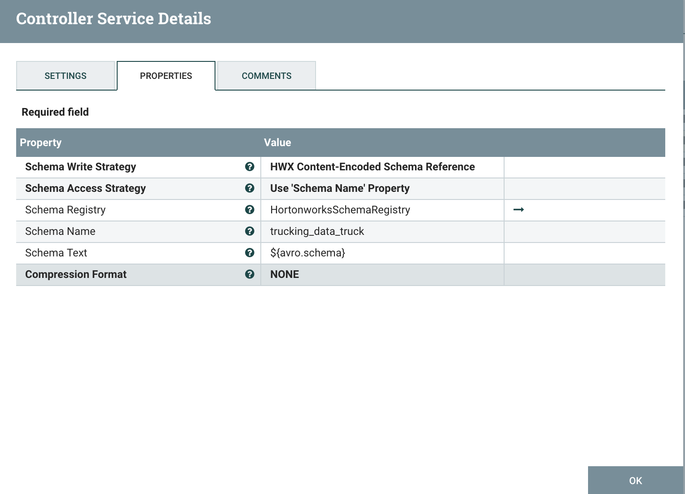

1. Copy the nifi-trucking-nar-0.3.2.nar from /home/user1 to /usr/hdf/current/nifi/lib. Restart nifi from ambari
2. In the nifi canvass drag and drop a processor and search for trucking and choose GetTruckingData.
3. Drag one more processor and search for trucking and select RouteOnAttribute
4. Connect the GetTruckingData to RouteOnAttribute and choose success for the relationship
5. Right click on the routeonattribute processor and in the settings tab click on auto terminate for unmatched

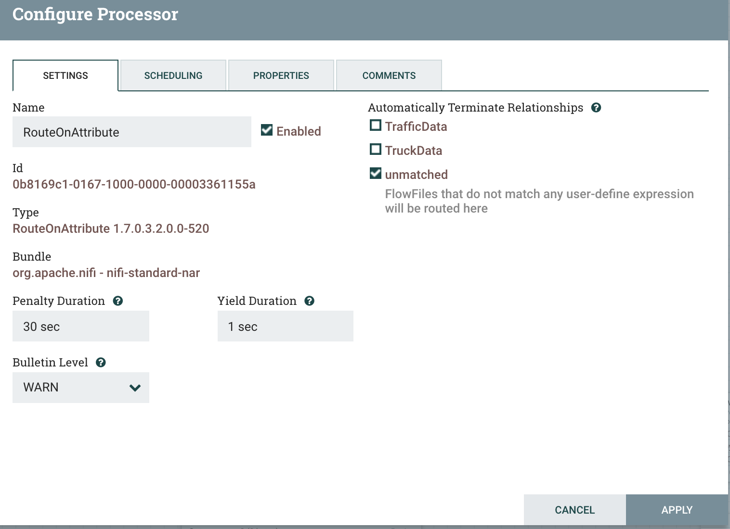

1. Drag and drop a processor and choose the EnrichTruckData processor.
2. Connect the routeonattribute processor to the enrichtruckdata processor and choose the TruckData in the connection

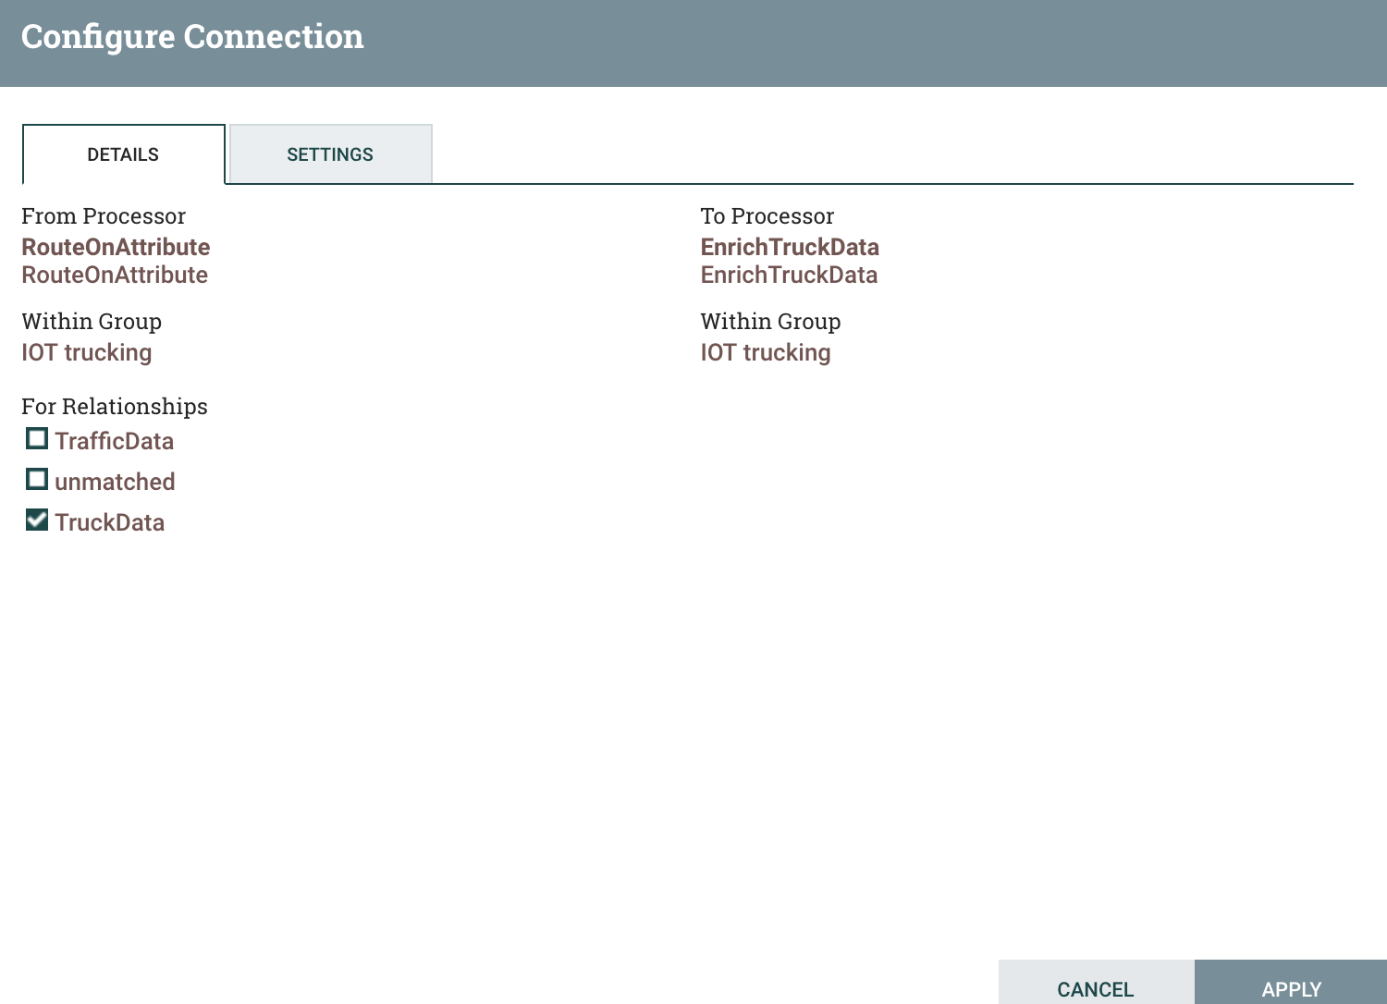

1. Right click on the routeonattribute processor and choose properties and set it to below

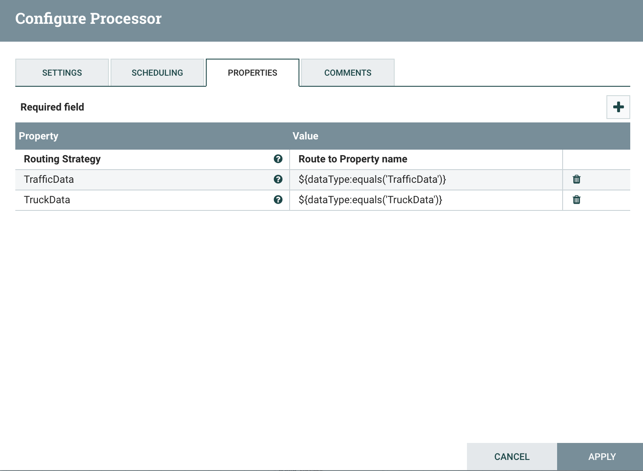

You need to click on + and add a property called TrafficData and set the value to ${dataType:equals('TrafficData')}. And add a property called TruckData and set the value to ${dataType:equals('TruckData')}

1. Add a convertrecord processor and connect the enrichtruckdata to the routeonattribute and select trafficdata in the connector
2. Right click on the convertrecord processor and set the properties to below. This processor convert data from csv to avro

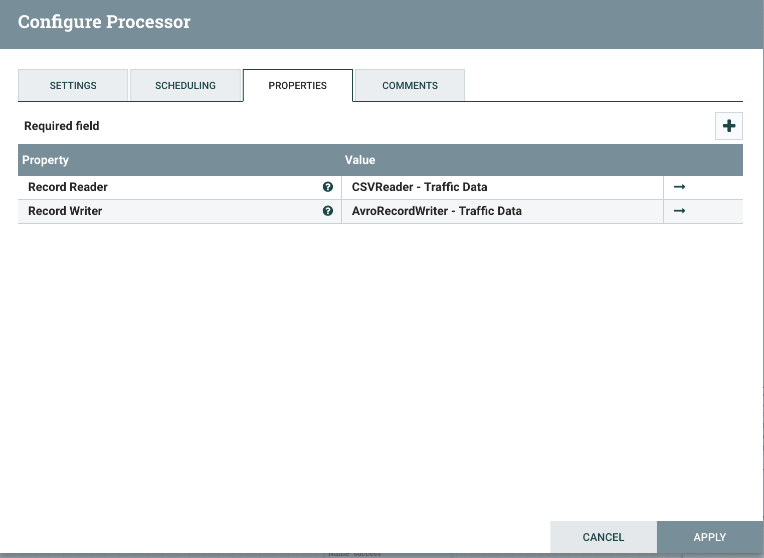

1. Add one more convertrecord processor processor and connect the EnrichTruckdata and choose success in the relationship
2. Add a PublishKafka_0_10 processor and connect it to the above convert record processor and set the properties as below

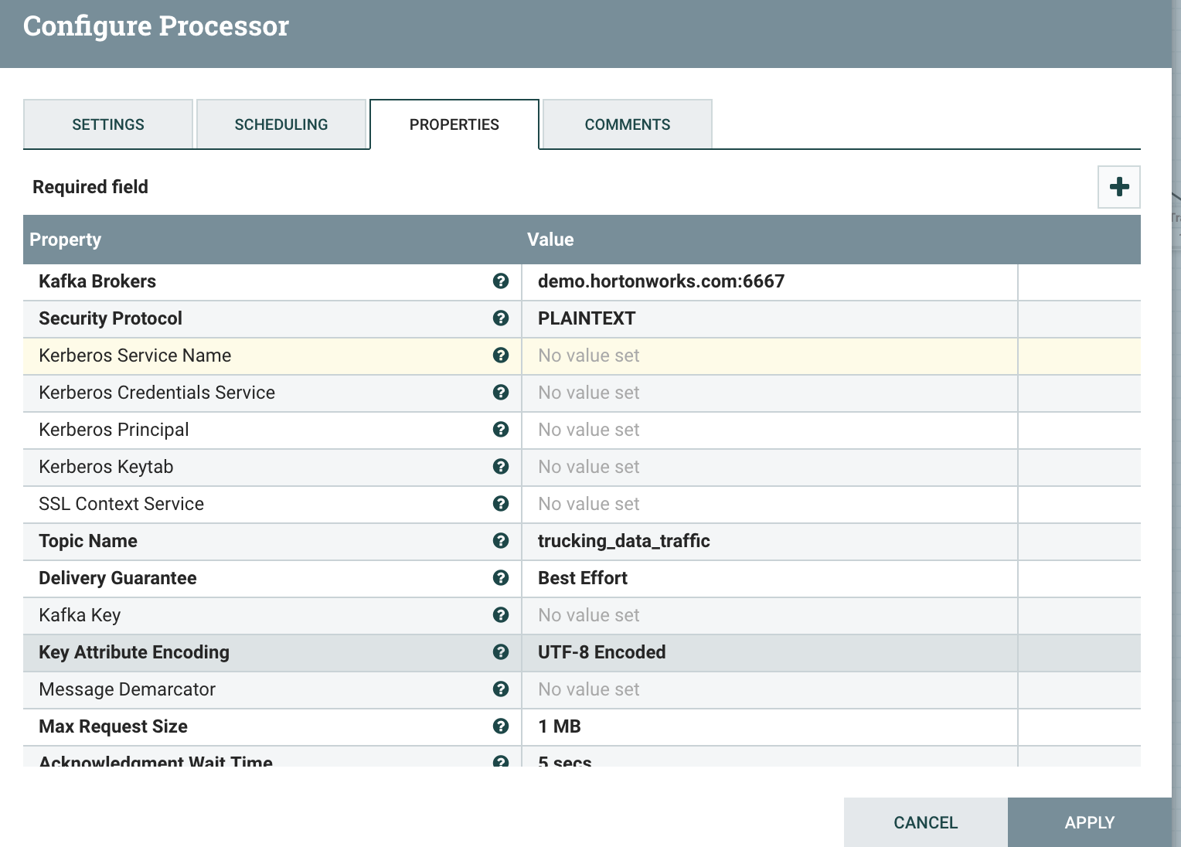

1. In the above convertrecordprocessor set the properties to below

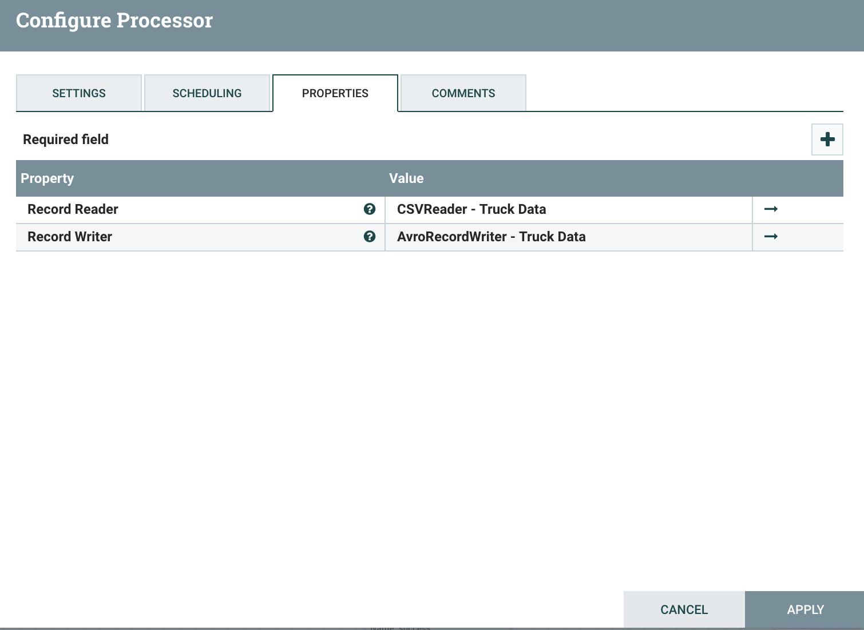

1. Add a PublishKafka_0_10. Processor and connect to the above convert record and set the properties as below

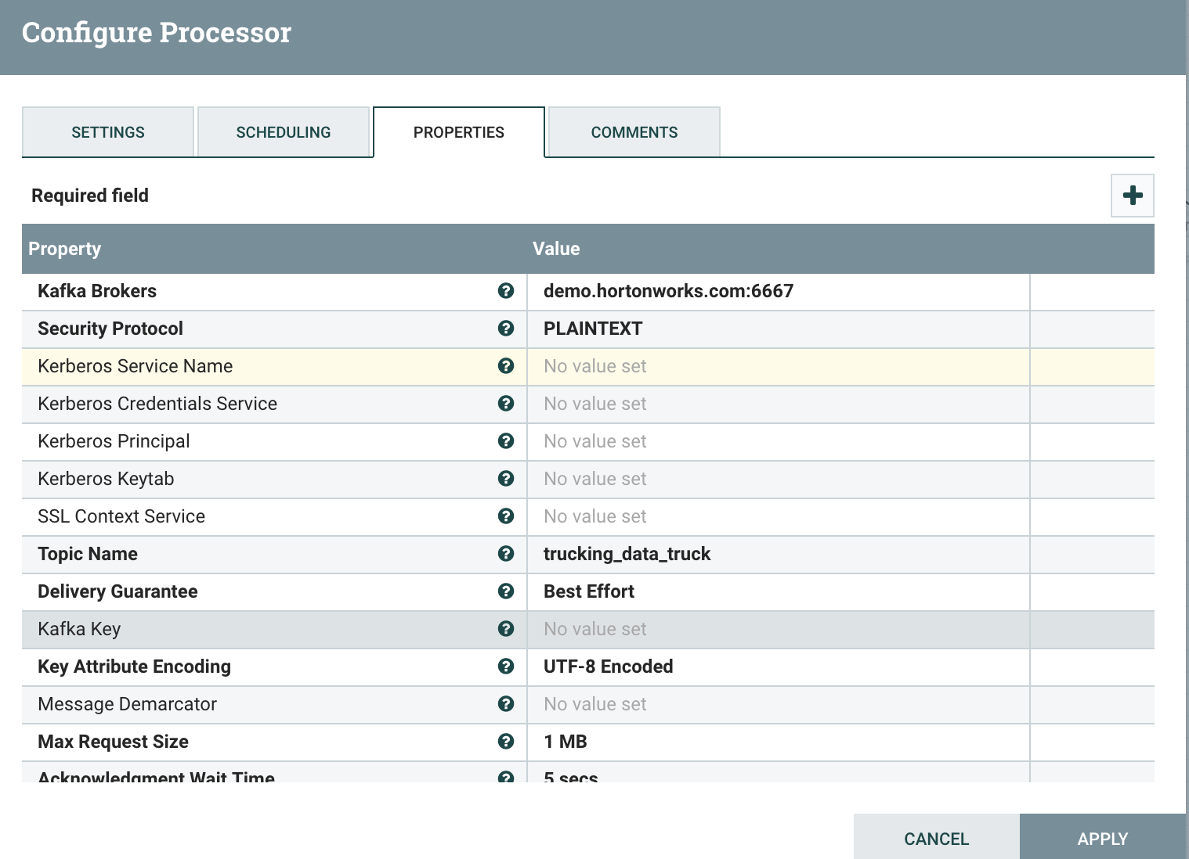

1. For reference the complete flow is at <https://github.com/vnarayaj/nifitrucking.git>
2. Do not start the flow now as we have not created the schema registry and kafka topics